Mar14/2016 Trading

On Sunday, March 13, 2016, several pieces of research were conducted whose results will be preliminarily discussed below.

On the issue of big loss:

Two variables were defined as

crash1 = cond(retCC<-0.03, 1,0)

crash005 = cond(retCC<-0.05,1,0)

logit crash1 monD-friD newBullIndicator amMaxT1 amMinT1 retOPC

Monday dummy is significant which means the chance of a Monday crash is very high. The order of safety (crash-resistant) is **Friday, Wednesday, Tuesday, Thursday, Monday.**

RetOPC also plays an important factor. When the index opens low, use lowest positioning.

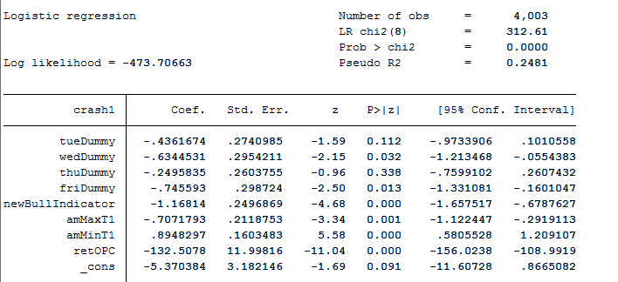

A sum of low positioning scenarios: Monday, Thursday, retOPC<0, newBullIndicator == 0.

Second results:

RetCL distribution:

**bysort weekday: su retCL**

Thursday has the lowest retCL ratio. Non Thursday weekdays have 1.08% of retCL, whereas Thursdays only have an average of 0.97% and this difference is statistically significant.

Bear market scenarios: retCL:

Mon: 0.77%

Tue: 1.04%

Wed: 1.02%

Thu: 0.82%

Fri: 0.89%

Bull Market retCL:

Mon: 1.4%

Tue: 1.1%

Wed: 1.2%

Thu: 1.1%

Fri: 1.14%

**The above is another source of justification for low positioning to be applied for Monday and Thursday for bear market scenarios.**

Monday, March 14, 2016

925

FTXIN9 opens up 41 bps, at a 0.03 premium.

What needs to be worked on is a probability calculator based on a logit regression. Probability(crash) = f(retOPC, retCCY, monD-friD,

1030 Update

hist dayMaxT1 if weekday == 1 & retOPC>0 & (amMinT1<9.75 | amMinT1>10.5) & amMaxT1>10.5



As can be seen from the graphs, max is 85% in the PM and dayMin is 85% in the AM.

Expected ending percentile is 85%. p25 p50 p75: 81%/95% 99%.

Therefore it is decided to hold the position until the end.

Today is a typical bullish Monday, reaping full benefits albeit with a small position. This was as previously planned to serve as a fall-safe in the case of

1341pm update

Max/Min distribution



Average retPMCO is 41bps. PmMaxT has 66% chance of appearing after 2pm. Therefore the position is to be held until tomorrow.

Markets started crashing from 1345pm, which shows the fidgeting nature of the market and also Monday. Small caps remain relatively strong while big caps take a beating (off 1.5% from its day highs). The expected rebound in the PM is still 50bps.

Like previously postulated, Monday is not an easy day to trade, I would rather not trade than risk losses. This again confirms with the statement that anything can happen and it is important to keep a small position in case of black swan events like this.

**3/15/16**

Shcomp opened -0.19%.

Research on the machine learning continues today. There were some preliminary results from yesterday which need to be tested.

Results from the R party package:

RetOPC<-0.8%

Buying has been a bit early. Look for real panic moments to enter into the market.

Second buy was entered @ 1224.

Both positions were profitable at day's end.

2259 Update

Today I have been thinking about the issue of increasing position size. The decision at the end is that I will temporarily **not** increase position and the maximum position is capped at 4 lots intraday, with 1 lot overnight. This is around 64% of the entire equity. This position is only eligible to be undertaken on Wednesday and Fridays with a retOPC > 0.002.

**It is important to keep working on position sizing and entry times and come up with a completely viable game-plan before position size is increased.** More research will need to be done especially in the case of catastrophic loss avoidance. Note even in the case of a proposed position size increase, the specific lots which will be eligible will be calculated by the **base case position sizing structure** (the irreducible [scenario, size] map) multiplied by a mechanical factor, in other words, **relative sizing between various scenarios is immutable**.

**A table will need to be compiled on all position size for all scenarios, given weekday, retOPC, newBullIndicator, amMaxT1 amMinT1 distribution, probability and expected return based on predicted values from R and logit regression from Stata.**

Recently a lot of quality work has been done in the field of position sizing, this includes the usage of low size in the case of Monday and Thursday, when retOPC < 0, amMaxT1<9.55, to name a few. These are extremely valuable results and further results will need to be explored in this field to come up with a complete system. Machine learning packages in R will be fully explored. Python and its related machine learning functionalities and capabilities will also be studied.

**Wednesday, March 16, 2016**

510050 opens down 50 bps. Discount retracted 50 bps.

Markets are nervous in front of the FOMC.

Update 1024

Intraday discount percentile dipped to -0.9% which was 20% percentile. Offshore investors are not willing to chase this rally. As we go into the afternoon it will be harder and harder for the short to cling onto their positions. Offshore investors are seemingly worried about the FOMC while mainland investors are not concerned at all.

Discount lingers around -0.8%. The discount makes sense because the edge today is not huge. There is 60% for the max and min to be in PM and AM respectively. People do not want to buy at all. Rally in the big caps continue as small caps are sold off, the discount goes to -0.9%.

After 1030, the probability shifts to 66/33 for both max and min. Afternoon's positive return is not statistically significant, albeit positive. Small caps continue to sell off.

Onshore IH discount is also around -1%, whereas the discount for IC is only 80bps. It is the first time I see such small discount for IC. 80 bps for IF.

Future traders are looking for a small cap rebound and a big cap retreat.

IH futures is at a 1.3% discount, IC is at a 60 bps discount.

Shcomp reached new highs. The max/min is over 70/30 for both now.

It is clear that the short in IH and the long in IC are having a very difficult time.

The very fact that investors are not convinced and there is not a consensus constitutes grounds for an index to go even higher. Only when consensus is achieved, real danger looms. Therefore it is good that there is not an agreement.

1120 Update:

3147 is at a 1.9% premium, reflecting people's reluctance to sell chinext.

P/D: IH: -1.5%. IC: -84 bps. IF: -1.1%

People continue being unconvinced about the big cap rally.

Discount goes to -1.71% for A50 futures. I will not buy here but I think it is a bargain here. Investors are very scared in front of the Fed. I like the smell of fear.

Bought 1 unit @ 9320 (1140). Reason is -1.73% discount, although I rarely chase highs, but at this level of discount (5% percentile), I felt obligated to take position. Liquidate this position at day's end.

Running distribution at noon:

Max: 30.77/70

Min: 38/62

Average retPMCO: 0.47% (testing against 0 rejects at 5% level)

Average retAMCO: 0.16%

Given the current situation, I decide to hold the position until the end.

PM session opens with -1.6% discount.

Cuing to sell @ 9400. There are a lot of offers on this level and it is hard to break this level.

Changing the cue to 9397.5, integer levels are very hard to fill.

The distribution of max and min is interesting. The max has 71% of being in the last 30 minutes. For the min, the weakness is expected to last until 14:30.

After last selling opportunity was missed, market starts to turn south very fast. The low open is weighing in on the market.

Market sentiment still feels very fidgety as investors look for every opportunity to sell. What I need is an opportunity to get rid of one lot before the end of day. Instead of putting the offer on 9400, put it on a tick less to get done, because historically this afternoon could be weak.

The later into the day, the more advantage I have.

It was difficult but the position was sold at 9400. This trade earned 80 USD.

90 bps was the discount contracting to 90 bps from 1.8%. 10 bps was lost due to the spot coming off softer.

1430 update:

IC future @ 80 bps discount. Continuous shifting into big caps is observed.

IH futures is at a 1.2% discount.

Today's day trade was done well. It took advantage of the distressed discount situation and the position was entered @ -1.8% discount and was liquidated when the discount was -80 bps.

As can be seen from the chart below, the discount was most pronounced during the lunch hour. It could be clearly sensed that market participants were very nervous today. IH futures closed @ -1.5% discount, IC closed flat (this is amazing), IF futures closed @ -91 bps.

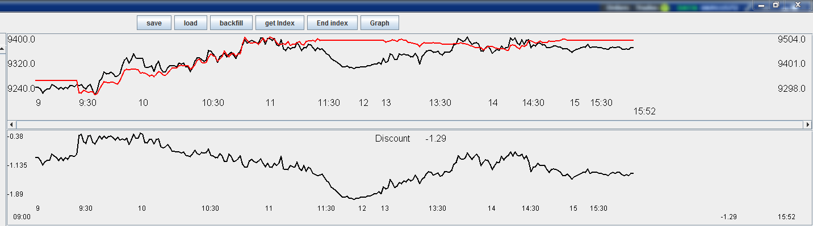

**Thursday, March 17, 2016**

Yellen kept rates unchanged this morning. US ETFs are at 1%-2% premium. Yesterday the position was liquidated @ 9395 going into Thursday. Today XU is expected to open at least up 1% to 1.5%.

I am looking to put on some position sometime today in preparation for tomorrow. Note that intraday trading today cannot exceed 2 lots.

A50 opens up 1%. The entire discount is erased. Thursday which is historically week, now the opening level is way above the highest level yesterday, it would be a good chance to short, however, I will wait for index to come off and enter into a long position. (Long position bias)

Cuing to short at 9490. The reason is that today's Thursday and the gap up is too exaggerated.

**Cancelled the order,** I feel uncomfortable with shorting at this point. If I had the long position I would have sold at this point. I will wait until the market comes off and enter a position to hold through the weekend. Examining the daily candles, the previous close is still above the 20DMA, look for opportunities to trade long -> do not short. Note that the conclusion was reached that only longs can be traded unless the previous close is clearly below the 20DMA. Today the market sentiment is bullish after the fed.

RetCC today given retOPC>0 is 0.35%. RetCO is 0.04%.

The problem with trading too early is because the situation is not that clear.

max/min distribution:

max(AM/PM): 55%/45%

min (AM/PM): 51%/49%

The max/min distribution seems to suggests that the morning will have a few swings.



Testing on retAMCO and retPMCO, there are no statistically significant results.

It is very clear at this point. An important thing note: **do not revenge the market by shorting when you have sold your long position too early. This has happened 2 weeks ago**. Even if today is Thursday, make sure to trade only in the direction of 20DMA.

Enter in times of panic. The level at which the position was built yesterday was at a discount of -1.8%, which was a very good position. Today is Thursday and the current discount is -0.3%. This position does not entice me to enter.

The panic has not taken place yet. The premium is at -20 bps. Onshore futures: IH is trading flat, IC is at a premium. IF is also trading flat. Market participants are very excited. The situation is quite dangerous given today's Thursday.

**1030 Update**

Market took a dive in the early AM. Low was achieved around 10:25. Thursday is week as usual.

amMinT1 is most likely be 11-11.5. AmMax most likedly appeared 9.5-10.

DayMax/DayMin distribution: As from the below charts, dayMax: 53%/47%. DayMin: 40% /60%.



Discount retreated to 50 bps.

RetCL is about 73bps.

RetPMCO is expected to be flat.

RetAMCO is -0.18%.

RetPMCL is 0.58%.

1100 update:

max/min

Max: 70/30. Min: 33/66.



The rebound retAMCL is very strong. Historically there has not been a rebound as strong as today. This may signal a bullish sentiment/mentality.

Historically:

. su retAMCL if weekday == 4 & retOPC>0 & amMinT1>11 & amMinT1<11.25 & ((amMaxT1>9.75 & amMaxT1<10))

Variable | Obs Mean Std. Dev. Min Max

-------------+---------------------------------------------------------

retAMCL | 11 .0039277 .0021699 .0005747 .0069174

Such a strong rebound is usually indicative of a bullish market. We will be able to examine against this hypothesis later. A50 futures keep going higher, currently @ -0.15% discount.

1401 Update:

Markets rally much stronger than expected and are in greed mode. Discount contract to less than -0.3%. Onshore futures: IC: 45 bps premium. IH trading flat. IF trading at 26bps premium. A lot of greedy behavior is apparent today. Markets remain very excited and this is strange on a Thursday. This was not consistent with the ex-ante distribution with the amMin after 11pm. Since this was not consistent with the expected probability distribution, it is ok to miss this trade. This demonstrates the notion of statistical causality as discussed by Elder, which says that bet size needs to be small because there are no sure events in trading, this is an important result because this forbids the use of big position sizes which might have catastrophic consequences. **Frequent usage of big position sizes is fatal because unlikely yet possible events can strike**. Position sizing is very important to undertake trades which are more likely in nature and withstanding 20% fluctuation on a position is necessary. (**Mar30/16 update: the rally was due to FOMC, and the unusually strong market session was indicative of the strong mentality**)

Big caps took a big plunge lower, which showed that the quick rally was greed based. Compared with the level at which I sold yesterday, the current level is about 40 bps higher. Below chart is from last Thursday. As can be seen, there are fake bullish outbursts once in the morning, once in the early afternoon. Market takes a major dive towards the end of the market due to the longs liquidating their position. The session was filled with greed and panic. In order to profit from these big swings, it is important not to chase, as I have been doing well. Today's probability distribution was such that the retCL was expected to be low. (mar30/16 update: the fact that even Thursday was this strong was indicative of a super bullish market, which lasted until the next Monday).

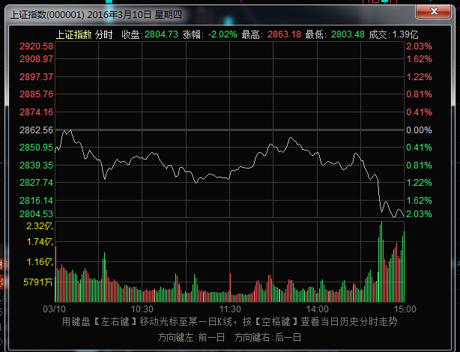

An interesting result regarding Thursdays:

RetCH = -96bps for Thursday, compared with -83bps for the rest of the weekdays, the difference is statistically significant. This means that Thursday tends to drop more severely from the highs, which was witnessed today and last Thursday, for example.

by weekday: su retCH if newBullIndicator yields

Mon: -0.42%, -0.58%, -0.58%, -0.65%, -0.61%

This means in bull market, there is still a considerable retreat from the highs. On bull market Mondays, there is considerable less retreat.

Today the correct decision made was not to short. It would have been a difficult session to go through with shorting. It is to be emphasized that no shorting is permitted during flat or bull markets.

The strong rally from the late morning session was suggestive of a bull market (the distribution was relatively weak as of this morning). Current discount @1540 is at flat, which means that investors are looking at a bullish day tomorrow.

The last buying point of the day was around 2:40, when the big caps were in a panic mode.

H share in contract jumped high, and traded in a small range. The movements in A shares are much more exaggerated due to the retail participation.

Today what was done right was sticking to the plan, trading only when probability allowed, secondly, quenched the urge to short the market this morning, shorting is a systematically losing tool in China. Now the strategy of intraday trading is working could possibly be due to newBullIndicator.

**Ranking of weekday retHL volatility:**

General: 1 > 2 > 4 > 3 > 5

**Ranking of weekday percentile:**

General: 2>1>3>5>4

Bull: 1>2>3>5>4

Bear: 2>3>5>1>4

Conclusion: 2/3/5 are good to trade mean reversion strategies (in this order). 4 is very dangerous and the lowest position has be used if trading. Monday varies a lot depending on bull/bear scenario (this is not a rigorous demarcation) and therefore small position needs to be used on this day as well.

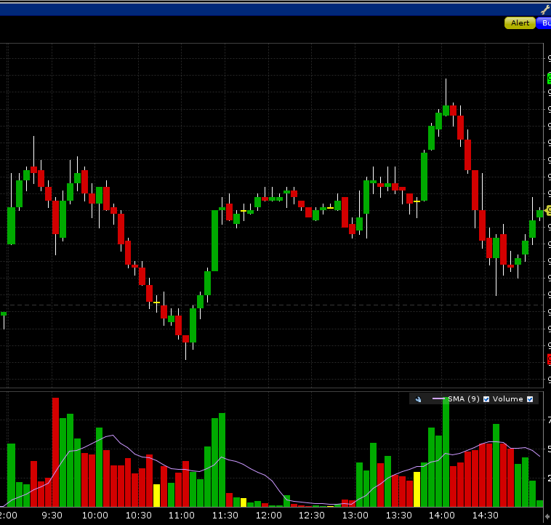

**Some insight on position sizing:**

Avoid trading on days where the retOPC < -0.8%. If want to trade, do not trade more than minimal size.

Trade on normal days when the index opens flat/high/more than -80bps, achieves a high later than 9:40. The key is to generate profits from orderless market movements.

Be careful of Mondays and Thursdays, trade minimal sizes on these days.

More machine learning techniques will be applied. Logistic regression, RWeka, e1071, rpart, party all these R packages will need to be thoroughly studied.

Always keep in mind the role of a liquidity provider. Never use liquidity (which means no hitting bid/lifting offer (this has been done well)). Never trade in a hurry, if level not met, wait.

Always able to withstand 20% swing in the market under all circumstances. This means that no more than 50% of total portfolio equity can be taken on at any given time.

**3.18**

Machine learning results:

> test <- ctree(dailyPricesData$closePercentile~retOPC+retCCY+monD+tueD+wedD+thuD+newBullIndicator+amMaxT1+amMinT1, controls=ctree_control(mincriterion=0.99))

I have some preliminary results to be verified. The model was done with ctree. The results indicate that the bullIndicator is the most important factor which separates the cases.

In bear market, the following cases are not tradable:

1. amMaxT<9:37, the index has about 70% of ending in the lowest 30% percentile.
2. AmMax>9:37, amMinT>11:16, retCCY>-1.5% . (50% of closing in the lows)
3. Thursday (note this is only in bear market scenario)
4. amMinT < 11:16, amMax<10:30, on all days.

Yesterday there seems to have been a trading mistake. Yesterday the highs were after 950, it would have made a good trading opportunity. This is why further research is needed and it is not wise to completely discredit Mondays and Thursdays.

**Essentially, models have to be built and observed values need to be updated in real time and plugged into the system to predict the returns, the dayMax, dayMin and ending percentile.** There seems to be bagging method to aggregate the different predictors for better results.

A50 futures is tracking index at 10bps, the market is very excited today and I don't want to enter here. Last afternoon was a good chance to enter (around 2:30 pm during the selloff).

Markets go into euphoria, all the futures are trading flat/premium. The buying point this morning was missed. The only opportunities were in the morning, and then there have not been any chances so far. A50 futures go into premium. Massive euphoria in the markets is observed.

Update 1127

Markets continue to rip higher. Onshore futures are still euphoric. IC : +17bps premium. IF: -21bps discount. IH: -10 bps discount.

After selling the position on Wednesday, there has been no position on the book. I missed out on about 200 USD of index movement. Make sure to have basic position consistent with the direction as the 20DMA.

Yesterday's mistake was the misjudgment of the probability of all day crash. This calls for the development of a model.

In retrospect of this week, the discount was most pronounced on Wednesday, and I was able to take advantage of that. After the fed event is over Thursday morning, the market quickly reverted to full acceleration mode. The reason why no trading was done on Thursday was due to the lack of understanding of the Thursday situation.

1321 Update

It is surprising to see how unwilling future traders are unwilling to sell. Futures are consistently at a premium. There is no panicking at all. CYB does not sell off at all.

The resistance of the futures is astonishing (the futures stay at a premium). There is no discount/premium advantage or intraday positional advantage. Nothing can be done at this point. As soon as the cash turns up a little, the futures are extremely bid, going into a premium. Market participants are expecting a huge rally which would close at the top percentile. While investors are feeling zealous, it is not the time to chase.

1339 update:

Discount goes down to -20bps. Investors are selling off a bit, while losing a bit of determination.

As market turns up a bit, buyers come back again. Today the markets are clearly extremely bullish. This is the first time I see the market so tenaciously bullish. A50 goes back to premium again.

All the onshore futures are at a premium: IH: 23bps. IC: 17bps. IF: 16 bps. (1351pm)

Again, the tenacity of the futures is absolutely amazing.

When the futures don't panic, that means the market is still in euphoria, which means it is still a dangerous level, when the market truly fears, that is a place of entry.

The probability is overwhelmingly in the bullish favor. Distribution of the dayMax below.



However, with this level of zealousness, it is very difficult to find an entry level.

All onshore futures are at a 50bps premium. A50 is trading at flat. The premium is impressive today.

Weekly review:

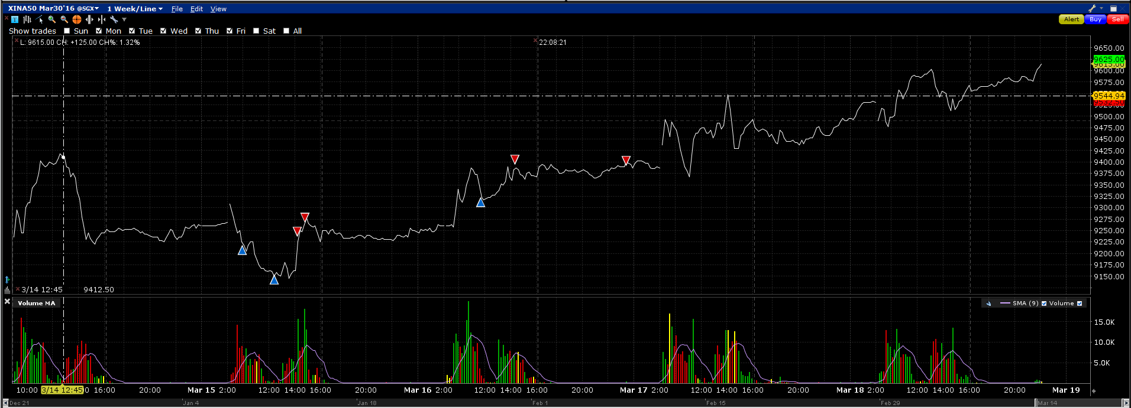

I only traded on Tuesday and Wednesday this week. The trades were well done.

On Thursday, due to the recently formulated rule that Thursdays are not as tradable, no trading was done. However, the model which was being formulated was not complete.

On Monday the index opened up 70 bps.

On Tuesday, the trades were well done.

On Friday the discount was super tight, investors were unwilling to sell throughout the whole day. As soon as the index showed any sign of recovery, the futures would shoot into premium. This has never been observed before. The new machine learning paradigm dictates that with a positive retOPC, the chance of a -3% day is 1%. This would have justified building a position in the early AM.

**Positive:**

No chase during the bullish moments. Exceptional discipline was demonstrated.

**Negative:**

Clear lack of knowledge about position sizing and how to identify risky scenarios.

Clear lack of awareness of the impact of retOPC on the probability of crashes.

Sold the remaining position too early during bull market.

**Need Improvement:**

Machine learning on bull market characteristics

Awareness of retOPC and retCCY need to be increased.

All machine learning methods need to be applied to data mine the historical data.

